**COUNCIL ASSESSMENT REPORT**

**SOUTHERN REGIONAL PLANNING PANEL**

|  |  |  |
| --- | --- | --- |
| **Panel Reference** | PPSSTH-303 | |
| **DA Number** | RA23/1004 | |
| **LGA** | Shoalhaven City Council | |
| **Proposal** | To construct and operate a waste resource learning centre on land within the Shoalhaven City Council West Nowra Recycling and Waste Depot. | |
| **Address** | 120 Flatrock Road, MUNDAMIA – Lot 1 DP 1018193 | |
| **Applicant** | Shoalhaven City Council c/- Terrior Pty Ltd | |
| **Owner** | Shoalhaven City Council | |
| **DA Lodgement Date** | 15 October 2023 | |
| **Application type** | Development application | |
| **Regionally Significant Criteria** | Schedule 6 Section 3(b) – Council related development over $5 million  The development has a capital investment value (CIV) of more than $5 million. | |
| **Capital Investment Value** | $7,071,769.10 (excluding GST) | |
| **Relevant Planning Matters** | * Shoalhaven Local Environmental Plan 2014 * State Environmental Planning Policy (Resilience and Hazards) 2021 * State Environmental Planning Policy (Biodiversity and Conservation) 2021 * State Environmental Planning Policy (Planning Systems) 2021 * Shoalhaven Development Control Plan 2014 | |
| **Documents Submitted for Consideration** | Refer to table below for full reference details  Attachment 1 - Architectural Plans  Attachment 2 - Acoustic Letter  Attachment 3- Arboricultural Impact Assessment  Attachment 4 - DA Report  Attachment 5 - Flora and Fauna Surveys and Biodiversity Impact Assessment  Attachment 6 - Bushfire Assessment Report  Attachment 7 - Existing Survey  Attachment 8 - Sediment & Erosion Control Plan  Attachment 9 - Sediment & Erosion Control Details  Attachment 10 - Typical Sections  Attachment 11 - Pavement Plan  Attachment 12 - Stormwater Drainage Details  Attachment 13 - Bulk Earthworks Plan  Attachment 14 - Siteworks Details  Attachment 15 - Civil Plans Cover Sheet  Attachment 16 - Specification Notes  Attachment 17 - Siteworks Plan  Attachment 18 - Stormwater Layout Plan  Attachment 18 - Stormwater Pit Schedule  Attachment 20 - Stormwater Catchment Plan  Attachment 21 - OSD & Bioretention Plan & Section  Attachment 24 - Geotechnical Report  Attachment 25 - Landscape Overall Plan  Attachment 26 - Operational Management Plan  Attachment 27 - Site Plan  Attachment 28 - Sketch Plan (over survey plan)  Attachment 29 - Statement of Environmental Effects  Attachment 30 - Traffic Parking and Access Report  Attachment 31 - Waste Management Plan  Attachment 32 - Waste Water Management Plan  Not attached - DRAINS and MUSIC Modelling | |
| **Section 4.6 requests** | NIL | |
| **Number of Submissions** | NIL | |
| **Key issues raised** | N/A | |
| **Recommendation** | Approval subject to conditions | |
| **Scheduled Meeting Date** | 20 November 2024 | |
| **Report Prepared by** | Consultant Planner: Louise Menday | |
| **Report date** | 4 October 2024 | |
| **Summary of s4.15 matters**  Have all recommendations in relation to relevant s4.15 matters been summarised in the Executive Summary of the assessment report? | | **Yes** | |
| **Legislative sections requiring consent authority satisfaction**  Have relevant clauses in all applicable environmental planning instruments where the consent authority must be satisfied about a particular matter been listed, and relevant recommendations summarized, in the Executive Summary of the assessment report? | | **Yes** | |
| **Section 4.6 Exceptions to development standards**  If a written request for a contravention to a development standard (clause 4.6 of the LEP) has been received, has it been attached to the assessment report? | | **Not applicable** | |
| **Special Infrastructure Contributions**  Does the DA require Special Infrastructure Contributions conditions (S7.24)? | | **No** | |
| **Conditions**  Have draft conditions been provided to the applicant for comment? | | **Yes** | |

# Executive Summary

The site of the proposal is on land described as Lot 1 DP 1018193, and known as 120 Flatrock Road, Mundamia. The land is within the existing West Nowra Waste Facility (the waste facility) that is owned and operated by Shoalhaven City Council and is located approximately 3km west of the Nowra town centre. The waste facility exists over several lots and accommodates a range of waste related activities, including landfill and materials recycling. The site of the proposal is in the southwest corner of the subject lot, near the entry to the waste facility off Flatrock Road.

The proposed learning centre will comprise three detached single storey buildings (an office and two general purpose buildings) with storage, kitchen and toilet facilities. The buildings will be set around a deck that will be used as an outdoor learning area. All construction is on piers and will be above ground level. A tall gabion wall will enclose the east and south side, and the entire site will be landscaped.

Car parking and bus parking, a bus drop off, and connecting paths will provide access. Cut and fill to provide a level area for construction, removal of trees, roadworks and sewage pump-out are proposed. Two existing buildings will be removed. One of these buildings is shown as ‘generator’ on the survey. Phytoremediation is shown in the landscape plan as a means of addressing soil contamination, and water contamination will be captured and treated in an expanded basin at the low point of the site (within an ‘exclusion zone’).

The land is zoned SP2 Infrastructure (Waste/Resource Management Facilities) under the *Shoalhaven Local Environmental Plan 2014* (SLEP 2014). The proposal is identified as *ordinarily incidental and ancillary* to the waste facility and is permissible with development consent.

The proposal has a capital investment value of more than $5 million. The application is made on behalf of Shoalhaven City Council as the landowner and intended operator of the proposed learning centre. The proposal is, therefore, regionally significant development as per Schedule 6 Section 3(b) of *State Environmental Planning Policy (Planning Systems) 2021*. Accordingly, the Southern Regional Planning Panel (the SRPP) is the consent authority for the development application.

This assessment demonstrates the proposal’s compliance with the relevant provisions of the following relevant environmental planning instruments:

* *Shoalhaven Local Environmental Plan 2014* (SLEP 2014)
* *State Environmental Planning Policy (Resilience and Hazards) 2021*
* *State Environmental Planning Policy (Biodiversity and Conservation) 2021*
* *State Environmental Planning Policy (Planning Systems) 2021.*

This assessment demonstrates the proposal’s general compliance with the following relevant chapters of the *Shoalhaven Development Control Plan 2014* (SDCP 2014):

* G1: Site Analysis, Site Design and Building Materials
* G2: Sustainable Stormwater Management and Erosion/Sediment Control
* G3: Landscaping Design Guidelines
* G4: Tree and Vegetation Management
* G5: Biodiversity Impact Assessment
* G7: Waste Minimisation and Management Controls
* G8: Onsite Sewage Management
* G21: Car Parking and Traffic.

Council notified and advertised the DA, in accordance with the *Environmental Planning and Assessment Regulation 2000* and the *Shoalhaven City Council Community Consultation Plan,* from 1 November 2023 to 29 November 2023. No submissions were received in response to notification.

This assessment finds the site is suitable for the proposed development. The development would have minimal environmental impact, would have a positive social benefit, and be in the public interest. This assessment concludes that the proposal can be approved, and the recommendation is that the application be approved in accordance with the stated reasons for approval and recommended conditions of consent.

# 1. Detailed Proposal

The proposal is to construct and operate a waste resource learning centre (the learning centre) on land within the Shoalhaven City Council West Nowra Recycling and Waste Depot (the waste facility), and includes:

* Removal of two existing buildings - one of which is shown as a generator
* Removal of five trees and retention of four, one of which is identified as a habitat tree
* Remediation of contaminated land
* Construction of the learning centre.
* Ancillary site works including carrying out of earthworks, construction of car parking, servicing, and landscaping.

Refer to **Attachment 1** – for a copy of the Architectural Plans.

The learning centre will comprise three detached single storey buildings (an office and two general purpose buildings) with storage, kitchen, and toilet facilities. The buildings will be set around a deck that will be used as an outdoor learning area. All construction will be on piers and will be above ground level. Shown schematically in **Figure 1**, the proposal consists of:

* Building A – 360m2 with multi-purpose room, kitchen, materials recycling room (accessed through the kitchen) and change room (accessed through the storeroom)
* Building C – 205m2 with ‘front of house’, lockers, toilets (male, female and accessible) and cleaner’s storeroom
* Building D – Approximately 120m2 identified as office with meeting room and kitchenette
* B & E – suspended decking about the same area as the building area, including outdoor learning space
* 5m high gabion walls around the east and south of the built form.

Figure 1. Schematic plan of built form and gabion wall (Source: Terrior 2023)

Car parking (26) and bus parking, a bus drop off, and connecting paths will provide access. A bus turning circle in the vicinity of the buyback area to the north of the site. Cut and fill, and removal of 5 trees, to provide a level area for construction, roadworks and on-site sewage management are proposed. Phytoremediation is indicated (in the landscape plan only) to address soil contamination and it is proposed to capture water and treat any contamination in an expanded basin at the low point of the site (within and ‘exclusion zone’).

The learning centre will accommodate social, recreational, environmental, professional and cultural groups, including school groups (pre-school to senior high school). Council staff will also use the learning centre for training and meetings.

Refer to **Figures 2, 3, 4** **and 5** for existing site plan, proposed site plan, proposed floor plan and sections respectively, and architectural plans at **Attachment 1**.

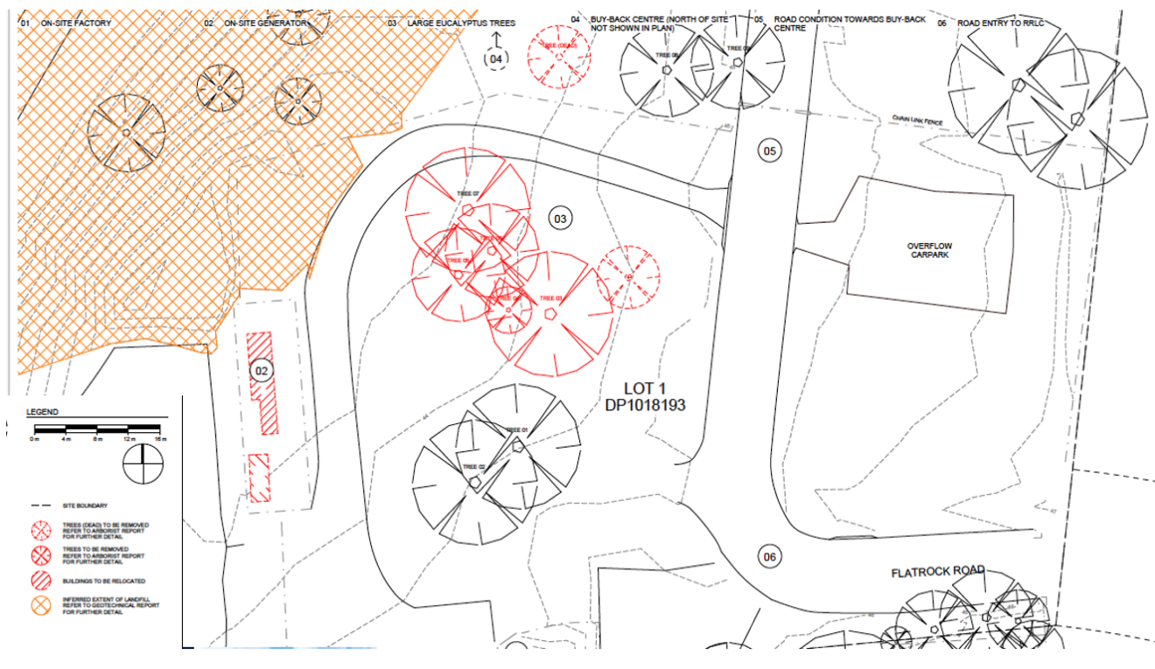

Figure 2. Existing site plan (Source: Terrior 2023)

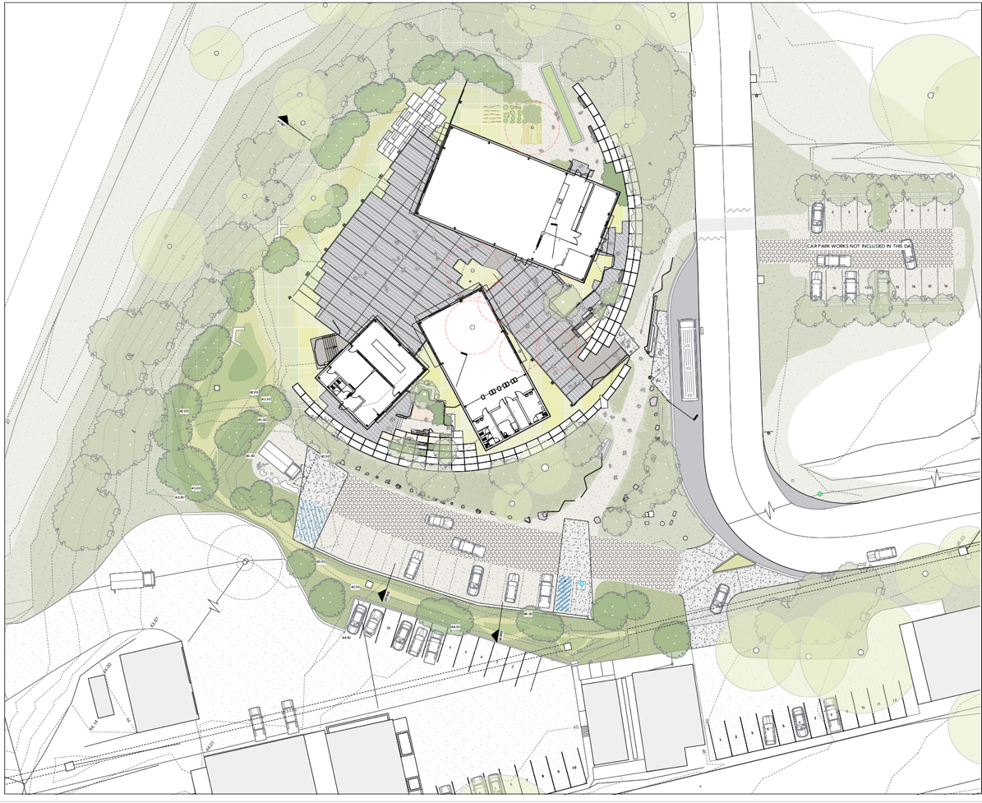

Figure 3. Proposed site plan (Source: Terrior 2023)

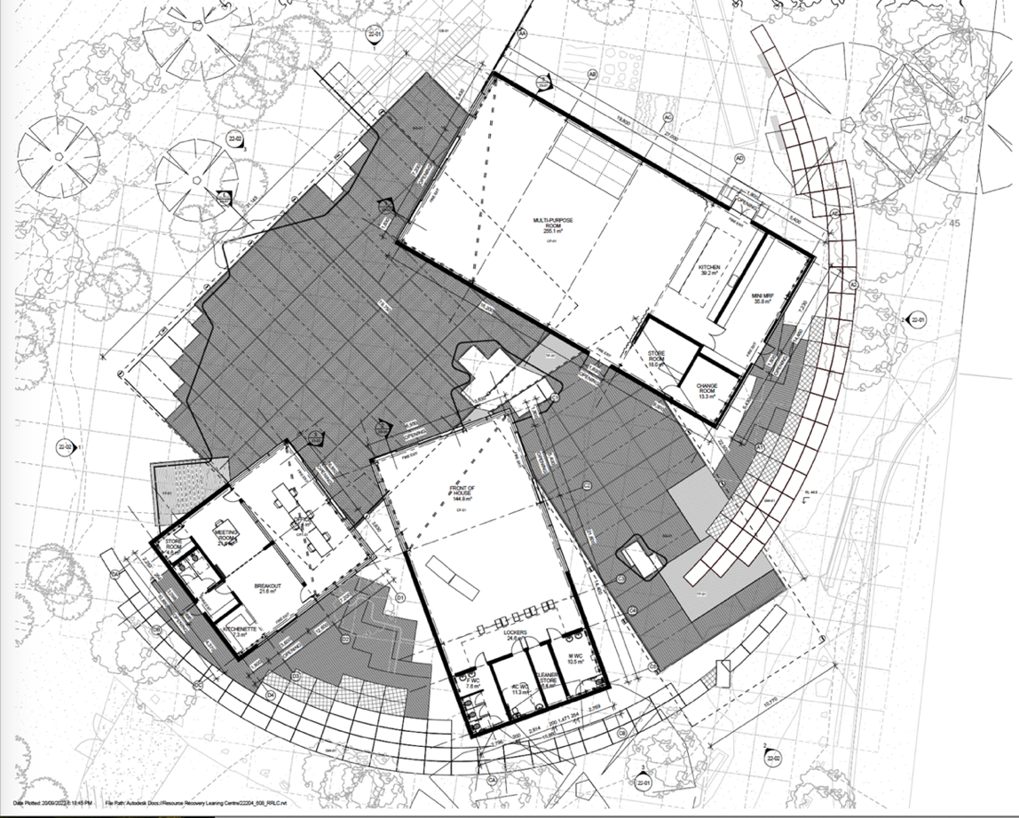

Figure 4: Proposed floor plan (Source: Terrior 2023)

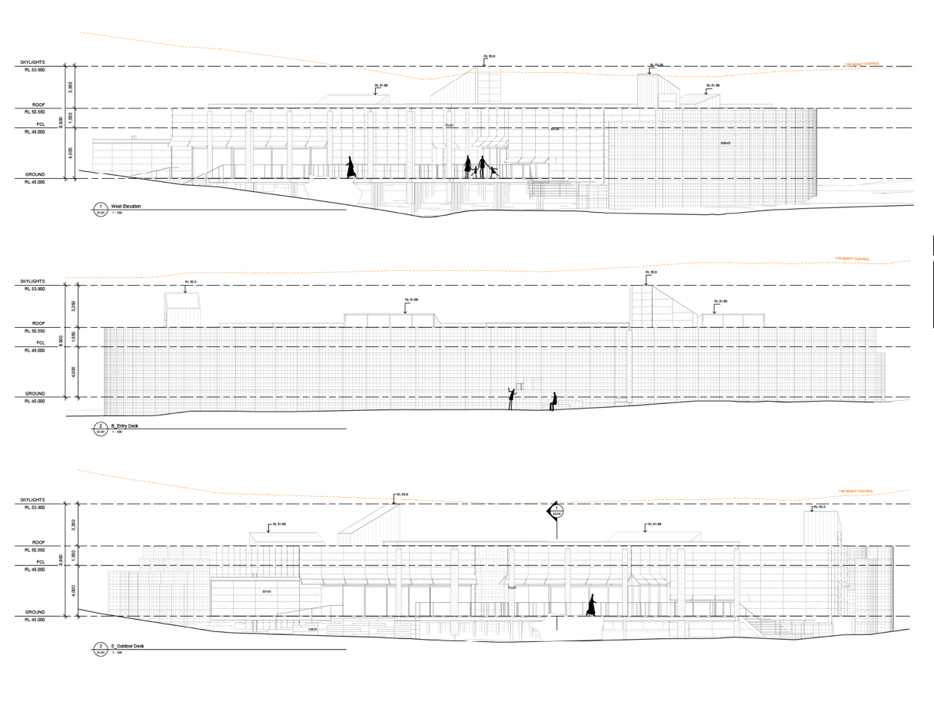

Figure 5: Proposed elevations (Source: Terrior 2023)

The following table lists the plans referred to in this assessment:

|  |  |  |  |  |
| --- | --- | --- | --- | --- |
| **TRIM Reference** | **Plan Title** | **Plan/Revision Number** | **Prepared By** | **Dated** |
| D23/404373 | Architectural Plans | DA 21-01 Revision 01  DA 22-01 Revision 01  DA 22-02 Revision 01  DA 23-01 Revision 01  DA 23-02 Revision 01 | Terrior Pty Ltd | 07/06/2023 |
| D23/404375  D24/218662  D24/218659  D24/218661  D24/218678  D24/218669 | Existing Survey  Sediment & Erosion Control Plan  Sediment & Erosion Control Details  Typical Sections  Pavement Plan  Stormwater Drainage Details | Issue 1 C1.03  Issue 1 C2.01  Issue 1 C2.03  Issue 1 C4.10  Issue 1 C4.21  Issue 1 C6.51 | Warren Smith Consulting Engineers | 14/07/2023 |
| D24/218658 | Siteworks Details | Issue 1 C4.11 | Warren Smith Consulting Engineers | 24/05/2024 |
| D24/218663  D24/218667  D24/218658  D24/218675  D24/218681  D24/318679  D24/218674 | Civil Plans Cover Sheet  Specification Notes  Siteworks Plan  Stormwater Layout Plan  Stormwater Pit Schedule  Stormwater Catchment Plan  OSD/Bioretention Plan/Section  Stormwater Drainage Details | Issue 2 C1.01  Issue 2 C1.02  Issue 2 C4.01  Issue 2 C6.01  Issue 2 C6.11  Issue 2 C6.21  Issue 2 C6.41  Issue 2 C6.52 – Sheet 2 | Warren Smith Consulting Engineers | 24/05/2024 |
| D23/404372 | Landscape Overall Plans | 22449-00-L001 Revision B  22449-00-L101 Revision B  22449-00-L102 Revision B  22449-00-L201 Revision A  22449-00-L202 Revision A | Realm Studios | 29/06/2023 |
| D23/404370 | Site Plan | DA00-02 Revision 01 | Terrior Pty Ltd | 07/06/2023 |
| D23/404383 | Sketch Plan (over survey) | Issue A Sheets 1-6 | Set Consultants | 14/11/2022 |

The following table lists the documents referred to in this assessment:

|  |  |  |  |  |
| --- | --- | --- | --- | --- |
| **TRIM Reference** | **Document Title** | **Revision Number** | **Prepared by** | **Dated** |
| D23/404361 | Acoustic Letter | The Project No. 22300 | S Skavo FLOTH | 16/05/2023 |
| D24/304696 | Arboricultural Impact Assessment | N/A | Tree Management Strategies | 18/07/2024 |
| D23/404400 | Appendix 1 – Tree Data Schedule (5 pages) | N/A | Tree Management Services |  |
| D23/404389 | Flora & Fauna Surveys and Biodiversity Impact Assessment | N/A | ACS Environmental | 28/08/2023 |
| D23/404390 | Bushfire Assessment Report | Ver 1.0 Final Issue | Set Consultants | 06/09/2023 |
| D24/218665 | DA Report | Issue E | Realm Studios | 21/05/2024 |
| D23/404403 | Geotechnical Report | Ref: 35556LTrpt | J K Geotechnics | 27/02/2023 |
| D23/513950 | Operational Management Plan | DA ISSUE | Shoalhaven City Council Waste Services | 07/12/2023 |
| D23/513939 | Statement of Environmental Effects v2 | L104083 V2 | Set Consultants | December 2023 |
| D23/404371 | Traffic Parking and Access Report | Issue A | People Trans | 15/09/2023 |
| D23/404357 | Waste Management Plan |  | Terrior Pty Ltd | 20/09/2023 |
| D24/377087 | Waste Water Management Plan | 3001-WW-A-02 | Broadcrest Consulting | 20/11/2023 |

# 2. Subject Site and Surrounds

The site is at the southeast corner of the subject lot. Lot 1 DP 1018193 is one of several lots that comprise the waste facility. The waste facility accommodates land fill (to the south west of the site) and recycling/recycled materials processes (such as tile manufacture from waste). The site is near the entrance to the waste facility off Flatrock Road and at the start of the internal road that travels north past the site to a controlled access/weighbridge, then turns and travels south (to the east of the site) to the landfill and other activities.

Concept and stage 1 approval has been granted for a materials recovery facility (MRF) on the land immediately to the east (known as 114 Flatrock Road, Mundamia) and the whole of that land has been cleared and levelled. The MRF will have a capacity to process 130,000 tonnes of waste (including composting and demolition waste) and will have its own vehicle access off Flatrock Road. Stage 1 works undertaken comprise demolition, clearing, grading, offices and amenities, new site entrance, site access roads, detention basins, car parking and asset protection zones.

Development consent has been granted for a materials recovery facility at the north west corner of the lot to the north of the site, that will have a capacity to process 24,000 tonnes of Council’s kerbside recycling materials. This MRF will have vehicle access off the internal road to the waste facility.

To the east of 114 Flatrock Road the land accommodates National Parks and Wildlife Services depot and offices.

The subject and adjacent lots that comprise the waste facility are substantially cleared. A paved internal road and various gravel roads provide access around the waste facility. Most of the waste facility is surrounded by bushland that is held in public reserves. Much of this land is zoned C1, C2 and C3. The nearest residence is about 500m from the site in an area that is rural residential in character.

The development is sited within a part of the land which contains nine trees, being Eucalyptus racemosa, punctata, and gumiffera. There is a low point that collects stormwater on the western side of the development area. A vegetated embankment rises to the west and the internal road for the waste facility sits above the embankment.

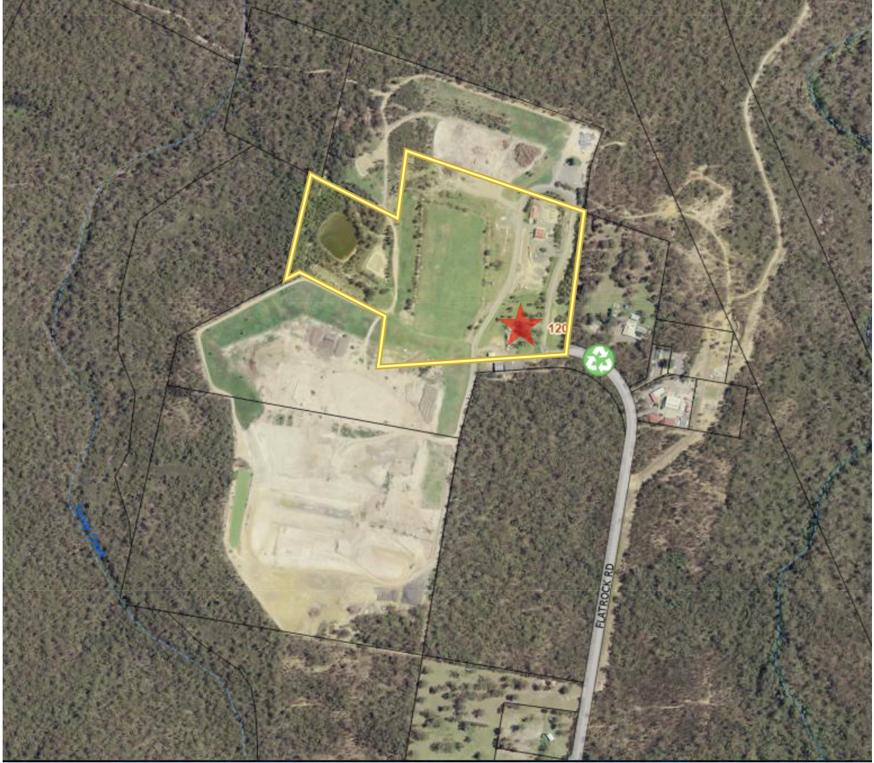

Figure 6: Learning centre location (red star) within lot 1 DP 1018193 (outlined yellow) and the wider West Nowra Waste Management Facility

Summary of Site Constraints

|  |  |  |
| --- | --- | --- |
|  | **Matter** | **Comment** |
| ***Basic*** | *Lot Area* | 130185m² - according to the SEE |
| *Zone* | SP2 Infrastructure (Waste/Resource Management Facilities) |
| *Easements/DP/88b Instrument Check* | No easements  88B instrument not available on GIS |
| *Does the property adjoin Council, Crown, National Parks or other public reserve?* | All sides of the site adjoin Council land |
| ***Topography*** | *Appropriate survey information provided?* | Yes |
| *Fall direction of land* | The land generally slopes downwards from east to west, however, also slopes down to a low point in the southern part of the site.  The bioretention basin it is located at the southern low point which would service the development. |
| *Slope of land >20%?* | No |
| ***Infrastructure*** | *Are works proposed in proximity to electricity infrastructure?* | No |
| *Adjacent to a classified road?* | No |
| *Adjacent to rail corridor?* | No |
| ***Utilities*** | *Access to reticulated sewer?* | No, wastewater disposal will be via collection well and pump out |
| *Suitable location of on-site sewage management and disposal areas?* | N/A |
| *Does the proposal require a new connection to a pressure sewer main?* | No |
| *Building over sewer policy applicable?* | No |
| *Access to reticulated water?* | Yes |
| *Suitable effluent management/disposal area buffers to water infrastructure?* | N/A |
| *Does the proposal impact on any critical water or sewer infrastructure* | No |
| *Does the proposal increase dwelling density and demand on water or sewer services?* | Yes, Shoalhaven Water require conditions regarding water service |
| ***Environment*** | *Aboriginal Cultural Heritage* | No |
| *Bush Fire* | Yes, RFS recommend conditions |
| *Coastal Hazard Lines* | No |
| *Coastal Hazard Area* | No |
| *Potentially Contaminated Land* | The site is known to be contaminated – refer to comments regarding preliminary site investigation. |
| *Water Quality* | Conditions required regarding stormwater retention and treatment |
| *Flood* | No |
| ***Planning*** | *Development within 40m of a watercourse* | No |
| *Development Control Plan -* [*Area Specific Chapters*](https://dcp2014.shoalhaven.nsw.gov.au/main-category/area-specific-chapters) | No |
| *Draft Exhibited Planning Proposal* | No |
| [*Acid Sulfate Soils*](https://legislation.nsw.gov.au/view/html/inforce/current/epi-2014-0179#sec.7.1) | Class 5 |
| Buffers | No |
| [*Terrestrial Biodiversity*](https://legislation.nsw.gov.au/view/html/inforce/current/epi-2014-0179#sec.7.5) | Yes - Habitat Corridor (however located outside of the extent of the development site area) |
| *Local Clauses* | No |
| [*Coastal Risk Planning*](https://legislation.nsw.gov.au/view/html/inforce/current/epi-2014-0179#sec.7.4) | No |
| [*Heritage*](https://legislation.nsw.gov.au/view/html/inforce/current/epi-2014-0179#sch.5) | No |
| [*Scenic Protection*](https://legislation.nsw.gov.au/view/html/inforce/current/epi-2014-0179#sec.7.8) | No |
| *Sydney Drinking Water Catchment area* | No |
| *SEPP (Resilience and Hazards) 2021 – Chapter 2 Coastal Management* | No |
| [*Marine Park Estate*](https://www.dpi.nsw.gov.au/__data/assets/pdf_file/0004/655699/NSW_Marine_Protected_Areas_Overview-Map.PDF) | [*Marine Park Estate*](https://www.dpi.nsw.gov.au/__data/assets/pdf_file/0004/655699/NSW_Marine_Protected_Areas_Overview-Map.PDF) |
| **Biodiversity Values** | *Is the site included on the biodiversity values map?* | No |
| **Compliance** | *Is the proposed development compatible with any relevant previous approvals?* | Yes |
| *Are there any orders applying to the property?* | No |
| *Does the proposal appear to include/relate to any unauthorised building work?* | No |

Pre and Post-Lodgement Information

|  |  |  |
| --- | --- | --- |
| **Action** | **Date** | **Summary** |
| Council pre-lodgment advice to applicant | 17/04/2023 | * Traffic and access * Stormwater drainage * JRPP triggers * Bushfire, contamination, acid sulfate soils, biodiversity |
| Council RFI to applicant | 18/10/23 | * Requesting operational management plan |
| Applicant response to RFI | December 2023 | * Operational management plan lodged |
| Referral to RFS | 24/10/2023 | Bushfire assessment report referred to RFS |
| RFS response letter | 7/11/2023 | RFS advice with recommended conditions |
| PPSTH Briefing | 01/11/2023 | Council staff and their planning consultant, and the applicant provided a preliminary briefing to the Panel |
| Council RFI to applicant | 11/04/2024 | * Wastewater * Biodiversity, tree management and landscaping * Stormwater, earthworks, traffic * OSD and WSUD * Waste bin presentation and management |
| Council email RFI to applicant | 16/04/2024 | * Requesting DRAINS and MUSIC modeling * OSD and stormwater quality, appropriate devices * Compliance with Council’s stormwater policies |
| RFI response | 25/07/2024 | * Wastewater addressed * Biodiversity and tree management addressed * Landscaping not addressed and has been conditioned * Stormwater, OSD and WSUD details amended after several Council emails and meetings – still not accurate and has been conditioned * Earthworks not addressed but enough information available to condition * Waste bin presentation not addressed and has been conditioned |

Timeline (NSW Planning Portal)

The application will be reported to the Shoalhaven City Council Ordinary Meeting on 12/11/2024 to advise Councillors of the recommendation to the Regional Planning Panel in accordance with *Council’s Community Consultation Policy for Development Applications (Including Subdivision)* POL22/8.

Site History and Previous Approvals

**DARTS – Since 1 July 2005**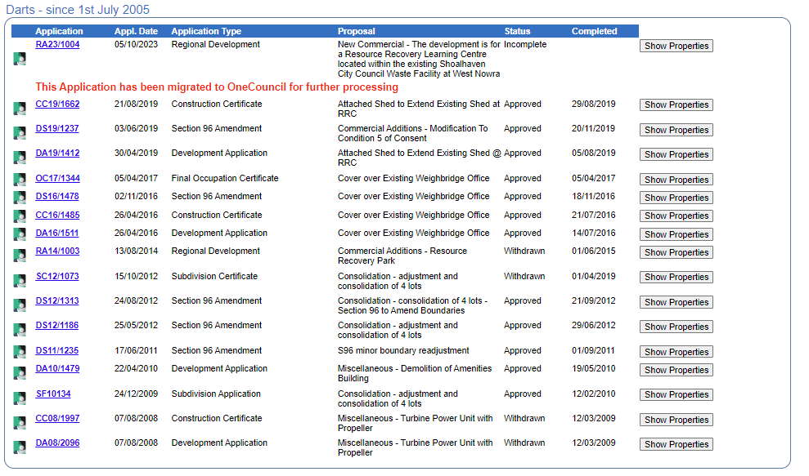

**Plain Sailing -Since 2 September 1996**

**Old Applications prior to 2 September 1996**

# 4. Consultation and Referrals

|  |  |
| --- | --- |
| **Internal Referrals** | |
| Referral | Comment |
| Biodiversity | No objection subject to conditions (referral response 12/09/2024).  The recommended consent conditions are included in the draft determination and the Biodiversity Officer’s detailed comments are included below where relevant (regarding Section 7.5 of SLEP 2014, and Chapters G3-G5 of the SDCP 2014). |
| Building Surveyor | No objection subject to conditions (referral response 28/11/2023).  The recommended consent conditions are included in the draft determination. |
| Development Engineer | No objection subject to conditions (referral response 03/04/2024 and 19/09/2024).  The recommended consent conditions are included in the draft determination and the Development Engineer’s detailed comments are included below where relevant (regarding Chapter G2 of the SDCP 2014 and stormwater management, Chapter G3 regarding some aspects of proposed landscaping, G21 regarding traffic and parking).  Planner Note: An amendment would be made to the recommended condition titled ‘Car Parking and Access Design Standards’ (subclause h) to ensure it does not conflict with the requirement from the Biodiversity referral and approved Arborist Report which requires the area within the Tree Protection Zone of Tree No. 1 to be constructed of permeable paving. |
| Floodplain Management and Water Quality Engineer | No objection subject to conditions (referral response 20 August 2024 and supplementary email dated 30 September 2024).  The recommended consent conditions are included in the draft determination and the Floodplain Engineer’s detailed comments are included below (regarding Chapter G2 of the SDCP 2014).  Planner Note: The referral response provided by the Development Engineer provides that: *Whilst there are some minor issues with the DRAINS model, it is considered generally acceptable. Due to the issues identified within the DRAINS model relating to the OSD volume calculations, it will be conditioned that the detailed OSD design is submitted to Council for approval prior to the approval of the CC. This is not anticipated to drastically alter the footprint of the basin.*  In this regard, whilst the Floodplain Management Section has recommended an updated strategy be submitted prior to determination – it is considered that this can be conditioned as per the advice provided by the Development Engineer. |
| Environmental Health Officer - Wastewater | No objection subject to conditions (referral response 12/09/2024).  The recommended consent conditions are included in the draft determination and the Environmental Health Officer’s detailed comments are included below (regarding Chapter G8 of the SDCP 2014). |
| Environmental Health Officer – Preliminary Site Investigation (PSI) | No objection subject to conditions (referral response 5 April 2024).  The recommended consent conditions are in the draft determination and the Environmental Health Officer’ detail comments are included below (regarding *State Environmental Planning Policy (Resilience and Hazards) 2021, Chapter 4 – Remediation of Land.* |
| Shoalhaven Water | Town sewer is not available. Standard conditions for water connection and Section 64 charges will apply (referral response dated 27/10/23).  The recommended consent conditions are included in the draft determination. |
| City Services (Waste) | No objection subject to conditions (referral response 24 October 2023 and supplementary email 30 September 2024). |
| City Services (Landscape Architect) | No response – however the landscape plan is addressed in the Biodiversity Officer’s response and conditions above. |
| City Services – Asset Strategy | No comments received. |
| City Services -Property | No comment (referral response dated 27/10/2023). |

|  |  |
| --- | --- |
| **External Referrals** | |
| Agency | Comment |
| Rural Fire Service | No objections subject to recommended conditions in letter referenced DA20231024004786-Original-1 (referral response dated 7 November 2023).  The recommended consent conditions are included in the draft determination. |
| Chamber of Commerce | No response or objection received within referral timeframe. |
| Local Aboriginal Land Council | No response or objection received within referral timeframe. |

# 5. Other Approvals

|  |  |
| --- | --- |
| **Integrated Development** | |
| **Agency** | **Recommendation** |
| NIL |  |

# 6. Statutory Considerations

***Environmental Planning and Assessment Act 1979***

**Section 4.14 Consultation and development consent – certain bush fire prone land**

|  |  |
| --- | --- |
| *Is the development site mapped as bush fire prone land?* | Yes |
| The bush fire assessment report, prepared by a suitably qualified consultant, identifies that the proposed development conforms to the relevant specifications and requirements of *Planning for Bush Fire Protection 2019*.  The NSW Rural Fire Service (RFS) considered the proposal (Council referral under s 4.14) and concurred that the development achieves compliance with the requirements under the Planning for Bush Fire Protection 2019, subject to the provided recommended consent conditions. A condition requiring compliance with the RFS letter of advice dated 7 November 2023 is included in the draft determination. | |

***Biodiversity Conservation Act 1979***

*Council’s Biodiversity Officer commented that entry into the Biodiversity Offset Scheme has not been triggered. A Biodiversity Development Assessment Report is not required. Also supported by the following.*

|  |  |
| --- | --- |
| *Does the application include works or vegetation removal within the* [*Biodiversity Values mapped area*](https://www.lmbc.nsw.gov.au/Maps/index.html?viewer=BOSETMap)*?* | No |
| *Does the application involve clearing of native vegetation above the area clearing threshold?*   | No |
| *Will the proposed development have a significant impact on threatened species or ecological communities, or their habitats, according to the test in* [*section 7.3*](https://legislation.nsw.gov.au/view/html/inforce/current/act-2016-063#sec.7.3) *of the Biodiversity Conservation Act 2016 (i.e. ‘test of significance)?*  *Note: Consideration should be given to the site’s proximity to NPWS land (see* [*guidelines*](https://www.environment.nsw.gov.au/-/media/OEH/Corporate-Site/Documents/Parks-reserves-and-protected-areas/Development-guidelines/developments-adjacent-npws-lands-200362.pdf)*) and other natural areas, as well as any area that may contain threatened species, vulnerable or endangered ecological communities or other vulnerable habitats.* | No |
| *If the application exceeds the Biodiversity Offsets Scheme Threshold (i.e. if yes to* ***any*** *of the above), has the application been supported by a Biodiversity Development Assessment Report (BDAR)?* | N/A |

## *Fisheries Management Act 1994*

The proposed development would not have a significant impact on the matters for consideration under Part 7A of the *Fisheries Management Act 1994*.

***Local Government Act 1993***

|  |  |
| --- | --- |
| *Do the proposed works require approval under* [*Section 68*](https://legislation.nsw.gov.au/view/html/inforce/current/act-1993-030#sec.68) *of the Local Government Act 1993?* | Yes - see s68 type nominated below |
| Water supply, sewerage and/or stormwater works  Operation of a system of sewage management (i.e. on-site sewage management system)  Installation of a manufactured home  Installation of a domestic oil or solid fuel heating appliance, other than a portable appliance (i.e. a fire place)? | |

# 7. Statement of Compliance/Assessment

The following provides an assessment of the submitted application against the matters for consideration under Section 4.15 of the EP&A Act.

# (a) Any planning instrument, draft instrument, DCP and regulations that apply to the land

## Environmental planning instruments

This report assesses the proposed development/use against relevant State, Regional and Local Environmental Planning Instruments in accordance with Section 4.15 (1) of the *Environmental Planning and Assessment Act 1979*. The following planning instruments and controls apply to the proposed development:

| **Environmental Planning Instrument** |
| --- |
| State Environmental Planning Policy (Planning Systems) 2021 |
| State Environmental Planning Policy (Biodiversity and Conservation) 2021 |
| State Environmental Planning Policy (Resilience and Hazards) 2021 |
| Shoalhaven Local Environmental Plan 2014 |

**State Environmental Planning Policy (Planning Systems) 2021**

The application is regionally significant development under Part 2.4 (Schedule 6 Section 3(b)) as it is development carried out by or on behalf of the Council that has an estimated development cost of more than $5 million. Accordingly, the development application is reported to the Southern Regional Planning Panel for determination.

**State Environmental Planning Policy (Biodiversity and Conservation) 2021**

**Chapter 4 Koala habitat protection 2021**

| **Question** | **Yes** | | **No** | |
| --- | --- | --- | --- | --- |
| 1. Is there an approved koala plan of management for the subject land? |  | Proceed to Question 2 |  | Proceed to Question 3 |
| 1. Is the proposed development consistent with the approved koala plan of management that applies to the land? |  | Proposal satisfactory under SEPP. |  | Application cannot be supported. |
| 1. Has information been provided to Council by a suitably qualified consultant that demonstrates that the land the subject of the development application:    1. Does not include any trees belonging to the koala use tree species listed in Schedule 2 of the SEPP for the relevant koala management area, or    2. Is not core koala habitat, or    3. There are no trees with a diameter at breast height over bark of more than 10cm, or    4. The land only includes horticultural or agricultural plantations |  | Proposal satisfactory under SEPP as (a), (b), (c) or (d) is satisfied. |  | Proceed to Question 4 |

**State Environmental Planning Policy (Resilience and Hazards) 2021**

**Chapter 4 – Remediation of Land**

The site is known to be contaminated, as confirmed in the Preliminary Site Investigation (PSI) lodged with the application. The PSI indicates the site can be suitably remediated for the proposed development and ongoing use. However, further investigation and appropriate documentation and processes need to be implemented. Council’s Environmental Health Officer provided the following comments regarding the PSI):

*A review of the PSI Report shows that the proposed site is highly impacted by the previous use as a landfill, as well as adjacent sites still in use.*

*While the proposed use of the site is considered low risk (hardstand areas, shallow footings and no vegetable gardens, etc) the proposed area for development has had high risk activities through use as a waste facility and continued use in sites adjacent.*

*Conditions will require a Detailed Site Investigation (DSI) prior to works being undertaken at the site. A Remediation Action Plan (RAP), Validation Report and Environmental Management Plan may also be required as part of the development.*

The recommended consent conditions are included in the determination to ensure the land is suitably remediated for its proposed use.

**Shoalhaven LEP 2014**

**Land Zoning**

The land is zoned SP2 Infrastructure (Waste/Resource Management Facilities) under SLEP 2014.

**Characterisation and Permissibility**

The proposal is best characterised as a waste and resource management facility (ancillary waste resource learning centre that is ordinarily incidental or ancillary to the primary use of the land) and is permissible with consent in the zone.

**SP2 Zone objectives**

|  |  |
| --- | --- |
| **Objective** | **Comment** |
| To provide for infrastructure and related uses. | The proposal is consistent with the zone objectives.  The nominated use of the land is *waste/resource management facilities.* The proposal is considered ordinarily incidental and ancillary to the nominated and active use of the waste facility, particularly as education is an emerging and growing component of waste management and resource recovery, encouraging reduced waste to landfill and more effective recovery and use of resources.  The proposal will support Council’s waste management and resource recovery activities and objectives by providing education about those activities and objectives on the site, to Council staff and the wider community. |
| To prevent development that is not compatible with or that may detract from the provision of infrastructure. |

**Applicable clauses**

|  |  |  |
| --- | --- | --- |
| **Section** | **Comments** | **Complies/Consistent** |
| Part 2 Permitted or prohibited development | | |
| **2.7**  Demolition requires development consent | Consent sought as part of this application. | Yes,  subject to conditions |
| Part 4 Principal development standards | | |
| **4.3**  Height of buildings | No maximum height is shown on the Height of Buildings Map. In accordance with section 4.3(2)(A) the maximum permitted building height on the site is 11m.  The SEE states the *proposed development does not exceed 11m, refer to plans*. The elevations and sections show the proposal is within the permissible height of 11m. | Yes,  subject to conditions |
| Part 7 Additional local provision | | |
| **7.1**  Acid sulfate soils | The subject site is identified as Class 5, and the works proposed to facilitate the development are not likely to lower the water table. The subject site is not within 400m to adjacent Class 1, Class 2 and Class 4 acid sulfate soils mapped land that is below 5m AHD.  Accordingly, an acid sulfate soils management plan is not required. | Yes |
| **7.2**  Earthworks | Council’s Development Engineer considered the extent of earthworks shown on the site long sections lodged with the application that indicate only a minor amount of cut and fill (<600mm).  The earthworks are considered to be acceptable and are found to be compliant with the objectives.  Standard conditions regarding earthworks and retaining walls are included in the draft determination. | Yes,  subject to conditions |
| **7.5**  Terrestrial biodiversity | Council’s Biodiversity Officer reviewed the Flora and Fauna Assessment and Arboricultural Report lodged with the application and undertook a site inspection that involved a general search for signs of threatened species and supporting habitat, such as hollow-bearing trees.  As a result, no objections are raised regarding the impact of the proposal on terrestrial biodiversity, subject to impact reduction measures that are include as consent conditions in the draft determination.  On this basis, the proposal is found to be compliant with the objectives within this section. | Yes,  subject to conditions |
| **7.11**  Essential services | All essential services can be made available, noting that sewage management will be via collection well and pump that is an acceptable solution given the site conditions. Water and electricity are available at the waste facility. | Yes |
| **7.12**  Council infrastructure development | The proposal involves construction of a class 9b building and is not exempt. Consent is sought in this application. | Yes |

## Draft Environmental Planning Instrument

None are applicable.

## Any Development Control Plan

**Shoalhaven DCP 2014**

|  |
| --- |
| Generic Chapters |
| **G1: Site Analysis, Sustainable Design and Building Materials** |
| **Satisfactory**  A suitable site analysis was lodged with the application (refer to the document titled DA Report by REALM dated 29/09/2023 issue D). Proposed material and finishes are suitable for the industrial character of the waste facility and include concrete, stone, metal and polycarbonate sheeting, steel grating and recycled timber. A condition is included in the draft determination that requires use of non-glare materials and finishes to the satisfaction of the principal certifier. |
| **G2: Sustainable Stormwater Management and Erosion/Sediment Control** |
| **Satisfactory subject to conditions**  **Water Sensitive Urban Design**  Council’s Floodplain and Water Quality Engineer provided the following comment (and draft conditions) regarding the proposal to collect and treat stormwater in the site’s low point, and expand the natural basin there (referral response dated 20 August 2024).  *It is noted that an Integrated Water Cycle Management Plan (IWCMP) has not been submitted to Council to support the development. The development footprint exceeds 2,500m2, as such, is a large-scale development in accordance with DCP Chapter G2.*  *Stormwater treatment has been proposed, with a graduated trash rack and sediment forebay upstream of an end-of-line bioretention basin. It is noted that the proposed stormwater treatment has been amended based on previous Council comments, and no longer proposes proprietary GPT’s and in-pit litter baskets. Details regarding access to inlets and outlets have been clarified in the Revised Bio-retention Basin Plans (D24/218658), with a minimum 3m average width buffer around the stormwater device proposed.*  *The DRAINS and MUSIC models have been reviewed. Please note the following:*   * *The bioretention basin includes a 400mm EDD* [*extended detention depth*] *and 400mm filter media depth. Further to this, it appears that that the OSD volume coincides with the EDD volume for stormwater treatment purposes. It is noted that Council typically require a 300mm EDD, 500mm MIN filter media depth, and OSD storage needs to be provided above the EDD volume with a staged outlet to manage water quality and OSD objectives in a single device footprint. Whilst some variation to EDD and filter media depth could be accepted if adequately justified, the design needs to accommodate OSD storage above the EDD storage, with a staged outlet structure provided.* * *The WSUD strategy comprises three swales to treat carpark runoff and a single bioretention basin. Draft conditions have been provided for these WSUD devices.* * *Based on the bioretention basin plans provided, the TP* [*total phosphorous*] *target of 45% has not been met. Some changes to the WSUD strategy are required to ensure the TP target can be met for the development.* * *The MUSIC model has used one year of continuous rainfall from 1/1/1959 to 31/12/1959. Please refer to DCP Chapter G2 Supporting Documents and MUSIC-Link for details of the required rainfall record to be utilised in Nowra. A 10 year representative rainfall record and evapotranspiration data is summarised in DCP Chapter G2 and MUSIC-Link. The MUSIC modelling needs to be updated with this meteorological data.* * *The bioretention basin EDD has been set as 0.1m in the MUSIC model. Council typically require a 0.3m EDD.* * *The bioretention basin treatment node needs to have a high-flow bypass equal to the 4EY* [*exceedances per year*] *flow.* * *The swales have a 2% MIN drain which is supported.* * *The GPT node is only capturing the roof runoff. However, it is noted that a trash rack is proposed for which there would be limited pollutant removal of TSS* [*total suspended solids*]*, TP and TN* [*total* *nitrogen*]*.* * *An updated MUSIC model needs to be provided to Council that addresses the above comments.*   *The proposed stormwater treatment train strategy is supported by Council and may comply with DCP Chapter G2. As noted above, some changes to the MUSIC model parameters are required and then the model needs to demonstrate that the MUSIC pollutant reduction targets in DCP Chapter G2 can be met.*  *Draft conditions of consent have been provided subject to confirmation that the proposed WSUD strategy can achieve the TSS, TP and TN pollutant reduction target of 80%, 45% and 45% respectively.*  *It is noted that internal Council discussions are required between Waste Services, Development Services, and City Services with regard to asset maintenance periods and handover for WSUD devices to the asset custodian. This referral includes Council’s standard conditions for the “Maintenance Period of WSUD Devices” and the “Handover of WSUD Assets to Council” under General Conditions.*  *An updated WSUD strategy and MUSIC model needs to be prepared which satisfy the requirements of DCP Chapter G2 D.*  In a supplementary email dated 30 September the Floodplain Engineer stated:  *For this site, it can likely be dealt with through a deferred commencement condition. An outcome of a revised strategy may be that the bioretention basin requires a greater footprint to comply with G2. However, I don’t think the site is overly space constrained so it should not be an issue (unless there are other constraints on site that I am not aware of, biodiversity etc.?).*  The recommended consent conditions are included in the draft determination. The conditions regarding asset maintenance periods and handover for WSUD devices to Council reflect Council’s standard periods but include a rider that these be subject to Council’s Floodplain and Stormwater Quality Engineer approval once the final design is determined (as per other conditions of consent).  Stormwater management, on-site detention, earthworks  Council’s Development Engineer provided the following comment regarding stormwater management (referral response dated 19 September 2024).  *The suite of documents submitted by the applicant on 27/05/2024 have been reviewed.*  *Whilst a earthworks plan has not been provided, the applicant has provided a couple of long sections through the site. These sections indicated only a minor amount of cut and fill (<600mm in height) is proposed and is therefore considered acceptable.*  *The submitted DRAINS model has been reviewed. Whilst there are some minor issues with the DRAINS model, it is considered generally acceptable. Due to the issues identified within the DRAINS model relating to the OSD volume calculations, it will be conditioned that the detailed OSD design is submitted to Council for approval prior to the approval of the CC. This is not anticipated to drastically alter the footprint of the basin.*  *The submitted MUSIC model has been reviewed by Council’s Floodplain and Water Quality Engineer – refer to their comments in this regard.*  The recommended consent conditions are included in the draft determination. |
| **G3: Landscaping Design Guidelines** |
| Satisfactory subject to conditions  Site analysis and approach for the landscaping design is provided in the DA Report. Features include   * Entry courtyard with seating * Staff courtyard with seating and above ground wicking garden beds * Enhanced natural water line * Water treatment at topographical low point * Ramped entry path lined with found objects * Bus drop-off zone * Retention and protection of four trees * Embankment planting and regeneration * Sculpture garden with above ground wicking garden beds * Gabion wall   Generally, the landscape plan is acceptable as it would result in an integrated landscape with the built form and reflects the constraints and natural features of the site. Council’s Biodiversity Officer provided the following comment regarding the landscape plan:   * *Planting schedule – native planting for the site should be selected from the local PCT 3654 Shoalhaven Lowland Bloodwood Shrub Forest. The document says this, but the planting schedule does not align with this PCT.* * *It is not appropriate to plant species that are not local to the area when creating a native garden that “considers the remnant ecology of the site and its surroundings” particularly threatened species that do not occur in the Shoalhaven and are unlikely to succeed in a landscaped setting (Eucalyptus aggregata, for example).*   Consent conditions included in the draft determination require that an amended landscape plan be provided and approved by Council prior to issue of a construction certificate. |
| G4: Tree and Vegetation Management |
| Satisfactory subject to conditions  Refer to discussion regarding G5: Biodiversity Impact Assessment |
| G5: Biodiversity Impact Assessment |
| Satisfactory subject to conditions  It is proposed to remove the trees numbered 3, 4, 5, 6 and two un-numbered dead trees, retain the trees numbered 1,2 and 8, and retain the tree numbered 9 that is unaffected by the proposal and will remain (refer to **Figure 8** below). The Arboricultural Report (Tree Management Services 18 July 2024) indicates the trees numbered 1, 2 and 8 will be impacted by the development. However, the report states that *with sensitive construction measures, tree protection and protect [sic] arborist supervision will remain health and viable.* An annual risk assessment for trees 1 and 2 is recommended to ensure their health, structure and the safety of people and property within their vicinity.  Tree Nos. 1, 2, 8 and 9 are to be retained as a part of this proposal, however the building footprint, in particular the planned gabion wall, is situated within the Tree Protection Zone of three (3) trees, one tree of particular significance in the landscape (see Figure 1 below). A site visit revealed that there are currently a pair of nesting Australian Kestrels with multiple young, a pair of nesting Galahs and several other bird species that utilise the dozen or so hollows within this significant old habitat tree. The Flora and Fauna Assessment Report also identified multiple bird species utilising this tree during their site visit and determined that several other birds, bats, and arboreal mammal species, including threatened species, may use this tree for habitat. This tree must not be impacted on by the development.  Council’s Biodiversity Assessment Officer reviewed an amended Arboricultural Report, and the Flora and Fauna Assessment lodged with the application. The Biodiversity Officer undertook a site inspection that involved a general search for signs of threatened species and supporting habitat (such as hollow-bearing trees) - no nocturnal or specialised targeted surveys were undertaken. The Biodiversity Officer provided the following comment:  *Mitigation to potential impacts to hollow-bearing tree reliant species will be the retention of Tree 1 which is full of hollows.*  *Tree Management Strategies (Arborist Report) recommend the following to mitigate the impacts of the proposal:*   * *Remove Trees 3, 4, 5, 6 and 7. Tree removal work to be undertaken in accordance with AS 4373 Pruning of Amenity Trees, using a qualified Arborist (minimum Australian Qualification Framework (AQF3) Level Arborist).* * *Adhere to the Tree Management Plan (Section 3) of this report [Arborist’s Report] to ensure the ongoing health of Trees 1, 2 and 8 to be retained.* * *A risk assessment by an AQF Level 5 arborist should be undertaken annually.*   *Based on the review and the results of the inspection Council can concur with the descriptions and assessment of the impacts by ACS Environmental (Flora and Fauna Assessment) and Tree Management Strategies (Arboricultural Report). The Biodiversity Officer has incorporated the consultant’s recommendations into recommended consent conditions/restrictions to users (referral response dated 12 September 2024).*    *Figure 8: Tree Location Plan (Tree Management Strategies, 28/11/2022)*  The recommended consent conditions are included in the determination. |
| **G7: Waste Minimisation and Management Controls** |
| Satisfactory subject to conditions.  A Waste Management Plan (WMP) was provided with the application. Demolition and construction waste materials will be removed from the site for recycling or disposal at landfill. Council’s Waste Services Officer commented that:  *The waste management plan provided is suitable for demolition and construction waste.*  *More information is required for the ongoing waste management of the site. The plan outlines that the site will participate in Councils kerbside collection service although further information is required on the proposed kerbside presentation point for bin collection and the suitability of the proposed bin storage area considering the distance required to wheel bins to the kerb and how patrons or workers of the site will access the bins. The applicant should consider a suitable bin storage enclosure or area that is easily accessible and visually complimentary to the design.*  The applicant did not provide amended details when requested for additional information on the ongoing waste management for the site. Consent conditions, therefore, will require details of ongoing waste management to be provided and approved by Council prior to issue of a construction certificate.  Council’s waste Officer gave further advice by email dated 30 September 2024 as follows. The applicant:  *previously indicated the use of Council’s kerbside collection service for ongoing waste and recycling management. Considering the site is not residential they can elect to arrange their own private waste collection contractor to provide the ongoing waste management. Should we be including both options into the condition for them to choose from?*  *Either option would still require them to detail the service and get approval prior to the issue of a construction certificate.*  Standard conditions regarding compliance with the waste management plan (for demolition and construction) are included in the draft determination. Consent conditions included in the draft determination require amended details regarding ongoing waste and recycling management be provided and approved by Council prior to issue of a construction certificate (with the option of private waste collection). |
| **G8: Onsite Sewage Management** |
| **Satisfactory subject to conditions**  The applicant provided an amended waste water report as requested by Council. Given unsuitable soil conditions, on-site disposal is not possible appropriate. The proposal is for a request well and pump out. Councill’s Environmental Health Officer provided the following comment on the amended Wastewater Report (referral response 12 September 2024).  *With the proposal for wastewater disposal to be via collection well and pump out the use of the kitchen is considered to be incorporated into the collection well sizing from calculations made from NSW Health Septic Tank and Collection Well Guidelines Part 4 (2001). Factories and Offices (WC, urinal, basin and kitchen).*  *The WW Report outlines the lack of suitability for on onsite disposal at the premises due to landfill surrounding the proposed development.*  *The proposal for a pump out arrangement suits the flows predicted of 1290L per day due to the development not providing showering facilities and servicing people visiting the education facility. The recommendations of the WW Report should be implemented for this development with conditions as recommended.*  The recommended consent conditions are included in the draft determination. |
| **G21: Car Parking and Traffic** |
| Satisfactory subject to conditions  Council’s Development Engineer advised the following (referral response 02/04/2024):  *I have reviewed the Traffic Impact Assessment undertaken by PeopleTrans and generally have no objections. As Council’s DCP does not have an equivalent parking rate, I concur with the assumption that it would be considered similar to a ‘entertainment’ function centre in parking terms and provided there is bus servicing proposed and adequate overflow parking areas on site, this is accepted.*   * *Conditions will be applied for the access road that goes to sheds southwest of site to have a stop sign and hold line installed to reduce risk of collision at this point of conflict.* * *Bus service bay and turn around area design generally supported.* * *Lighting will be conditioned with Council’s standard conditions.*   An assessment of the provided car parking has revealed that parking would be sufficient for the site. It is further noted that a future overflow parking to be proposed to cater for any increased demand where required. Parking would also be offset by provisions for buses – noting that persons attending the site may also be from local schools who would attend via public transport, rather than in their own private vehicles.  The recommended consent conditions are included in the draft determination. |

## iiia) Any planning agreement that has been entered into under section 7.4, or any draft planning agreement that a developer has offered to enter into under section 7.4

NIL

## Environmental Planning and Assessment Regulation 2021

Council’s Building Surveyor did not raise any relevant issues. No parts of the EP&A Regulation 2021 are specifically applicable. No areas of concern are raised as a result of a review of the Regulations.

## Any coastal zone management plan

Not applicable.

## Section 7.11 - Shoalhaven Contribution Plan 2019

The proposed development is not considered to trigger Shoalhaven Contribution Plan 2019 as it is to be provided by Council for a Council project that is to provide non-profit community facilities.

|  |
| --- |
| (b) The Likely impacts of that development, including environmental impacts on the natural and built environments, and social and economic impacts in the locality |

| **Head of Consideration** | **Comment** |
| --- | --- |
| Natural Environment | The site is mostly cleared of natural vegetation, except for nine mature Eucalypt species. Council’s Biodiversity Officer assessed proposed tree removal, retention and protection and concurred with the Floral and Fauna and tree management documentation lodged with the application. The draft determination requires retention of the hollow bearing habitat tree and its protection along with three others.  Site contamination will be improved through remediation. Stormwater will be captured on site and treated to improve water quality before release into the wider drainage system. Replacement planting will use local species.  Subject to recommended consent conditions as detailed in this report, it is considered there will be no adverse impacts on the natural environment, and potential improvement as outlined above. The proposal will have an acceptable impact on the natural environment with compensatory planting and improvement soil and water. |
| Built Environment | The architectural plans present a modern and simple built form. With the use of robust and earthy material the proposal will be compatible with the landscaping on the site and surrounds, and will be compatible with the basic character of the waste facility.  Subject to recommended consent conditions as detailed in this report, it is considered there will be no adverse impacts on the built environment and potential improvement with the introduction of a well-designed built form and integrated landscaping. |
| Social Impacts | There will be positive social impacts. The development of a contemporary waste resource learning centre aligns with Shoalhaven City Council’s vision for waste management (as stated in its Waste Reduction Management Strategy 2022 – 2027) *to reduce waste generation, maximise recovery and minimise disposal*.  The learning centre will accommodate social, recreational, environmental, professional and cultural groups, including school groups (pre-school to senior high school). Council staff will also use the learning centre for training and meetings. |
| Economic Impacts | There will be no adverse economic impacts and the end goal, being waste reduction, will have a positive economic impact. |

|  |
| --- |
| (c) Suitability of the site for the development |

The proposal is for a learning centre, ancillary car parking and landscaping, within an established waste management facility. The site conditions are adequately assessed in the site analysis lodged with the application and the proposal responds well to these with a compatible architectural design and integrated landscape, traffic and pedestrian access. The proposal is supported by environmental measures and protections in tree preservation, soil improvement and stormwater and waste management to ensure it makes best use of the site.

As demonstrated in this assessment, the proposal complies with relevant planning controls and meets the requirements of Shoalhaven DCP 2014 and represents an efficient and effective use of public land within the waste facility. Subject to recommended conditions of consent, it is considered that the site is suitable for the development.

|  |
| --- |
| (d) Submissions made in accordance with the Act or the regulations |

The application was notified in accordance with the Environmental Planning and Assessment Regulation 2000 (EP&A Regs) and Council’s Community Consultation Policy for Development Applications from **1st November 2023** to **29th November 2023.**

No submissions were received by Council in response to the notification of the development application.

# (e) The Public Interest

The proposed development generally complies with relevant State Planning Policies, the provisions of SLEP 2014 and is broadly consistent with the requirements of the SDCP 2014. Subject to conditions of consent the development is not expected to have any unacceptable negative impacts on the environment, or the amenity of the locality. Given positive social and environmental benefits the proposal is considered to be in the public interest.

# Delegations

## Guidelines for use of Delegated Authority

Given the proposal is Regionally Significant Development (satisfying the criteria of section 3(b) of Schedule 6 of SEPP (Planning Systems) 2021, the application must be determined by the Panel.

# Recommendation

This application has been assessed having regard for Section 4.15 (Matters for consideration) under the Environmental Planning and Assessment Act 1979.

Relevant Council officers have undertaken detailed analysis of the proposal, its impacts and compliance. As discussed in this assessment, issues have been resolved during assessment of the application, including documentation amended at Council’s request. This assessment resulted in a better understanding of the impacts and benefits of the proposal.

The proposal is considered to meet the provisions of relevant state environmental planning policies and the relevant provisions and objectives of the SLEP 2014 and SLEP 2015.

The application is considered capable of support as there are no substantive planning reasons to warrant refusal. As such, it is recommended that Development Application No. RA23/1004 be approved subject to appropriate conditions of consent.